**Assignment No. 03**

**Title:** [**Web Design and Programming Lab-I**](https://classroom.google.com/u/2/c/Njc5NTg4OTk0MTU0)

*Course title: Structured Programming Language*

*Course code: CSE-312*

*3rd Year 1st Semester Examination 2023*

**Date of Submission**: 13-Sep-2024



**Submitted to-**

###### **Md. Rafsan Jani**

*Assistant Professor*

*Department of Computer Science and Engineering*

*Jahangirnagar University*

*Savar, Dhaka-1342*

|  |  |  |  |
| --- | --- | --- | --- |
| **Sl** | Class Roll | Exam Roll | Name |
| 01 | 383 | 210903 | Abdullah Nazmus-Sakib |

|  |
| --- |
| **Problem Number:04** |

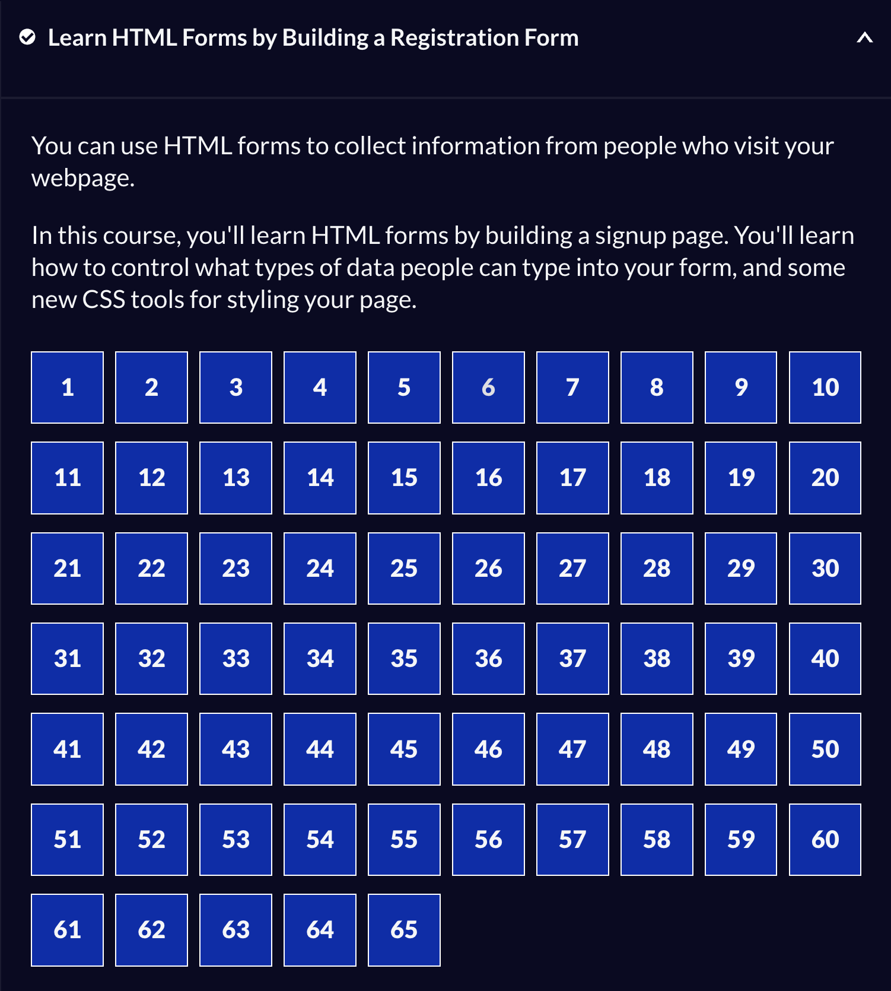github link: <https://github.com/AbdullahRFA/Project/tree/main/Registration_form>

|  |
| --- |
| **Problem Number:4** |

Source Code:

Index.html

<!DOCTYPE html>

<html lang="en">

<head>

<meta charset="UTF-8" />

<title>Registration Form</title>

<link rel="stylesheet" href="styles.css" />

</head>

<body>

<h1>Registration Form</h1>

<p>Please fill out this form with the required information</p>

<form method="post" action="https://register-demo.freecodecamp.org">

<fieldset>

<label for="first-name"

>Enter Your First Name:

<input id="first-name" name="first-name" type="text" required

/></label>

<label for="last-name"

>Enter Your Last Name:

<input id="last-name" name="last-name" type="text" required

/></label>

<label for="email"

>Enter Your Email:

<input id="email" name="email" type="email" required

/></label>

<label for="new-password"

>Create a New Password:

<input

id="new-password"

name="new-password"

type="password"

pattern="[a-z0-5]{8,}"

required

/></label>

</fieldset>

<fieldset>

<legend>Account type (required)</legend>

<label for="personal-account"

><input

id="personal-account"

type="radio"

name="account-type"

class="inline"

checked

/>

Personal</label

>

<label for="business-account"

><input

id="business-account"

type="radio"

name="account-type"

class="inline"

/>

Business</label

>

</fieldset>

<fieldset>

<label for="profile-picture"

>Upload a profile picture:

<input id="profile-picture" type="file" name="file"

/></label>

<label for="age"

>Input your age (years):

<input id="age" type="number" name="age" min="13" max="120"

/></label>

<label for="referrer"

>How did you hear about us?

<select id="referrer" name="referrer">

<option value="">(select one)</option>

<option value="1">freeCodeCamp News</option>

<option value="2">freeCodeCamp YouTube Channel</option>

<option value="3">freeCodeCamp Forum</option>

<option value="4">Other</option>

</select>

</label>

<label for="bio"

>Provide a bio:

<textarea

id="bio"

name="bio"

rows="3"

cols="30"

placeholder="I like coding on the beach..."

></textarea>

</label>

</fieldset>

<label for="terms-and-conditions">

<input

class="inline"

id="terms-and-conditions"

type="checkbox"

required

name="terms-and-conditions"

/>

I accept the

<a href="https://www.freecodecamp.org/news/terms-of-service/"

>terms and conditions</a

>

</label>

<input type="submit" value="Submit" />

</form>

</body>

</html>

Styles.css

body {

width: 100%;

height: 100vh;

margin: 0;

background-color: #1b1b32;

color: #f5f6f7;

font-family: Tahoma;

font-size: 16px;

}

h1,

p {

margin: 1em auto;

text-align: center;

}

form {

width: 60vw;

max-width: 500px;

min-width: 300px;

margin: 0 auto;

padding-bottom: 2em;

}

fieldset {

border: none;

padding: 2rem 0;

border-bottom: 3px solid #3b3b4f;

}

fieldset:last-of-type {

border-bottom: none;

}

label {

display: block;

margin: 0.5rem 0;

}

input,

textarea,

select {

margin: 10px 0 0 0;

width: 100%;

min-height: 2em;

}

input,

textarea {

background-color: #0a0a23;

border: 1px solid #0a0a23;

color: #ffffff;

}

.inline {

width: unset;

margin: 0 0.5em 0 0;

vertical-align: middle;

}

input[type="submit"] {

display: block;

width: 60%;

margin: 1em auto;

height: 2em;

font-size: 1.1rem;

background-color: #3b3b4f;

border-color: white;

min-width: 300px;

}

input[type="file"] {

padding: 1px 2px;

}

.inline {

display: inline;

}

a {

color: #dfdfe2;

|  |
| --- |
| **Problem Number: project** |

Github Link: <https://github.com/AbdullahRFA/Project/tree/main/Student_survey_form>

Source code:

Index.html

<!DOCTYPE html>

<html lang="en">

<head>

<title>Survey Form</title>

<meta charset="utf-8">

<link rel="stylesheet" href="styles.css">

</head>

<body>

<h1 id="title">Student Survey Form</h1>

<p id="description">Thank you for giving your valuable time to complete this survey.</p>

<form id="survey-form">

<fieldset class="f1">

<label id="name-label" for="name">Enter your name</label>

<input id="name" type="text" name="name" required placeholder="Name">

</fieldset>

<fieldset class="f1">

<label id="email-label" for="email">Enter your E-mail</label>

<input id="email" type="email" name="email" required placeholder="E-mail">

</fieldset>

<fieldset class="f1">

<label id="number-label" for="number">Enter your age</label>

<input id="number" type="number" name="age" min="8" max="255" required placeholder="Age">

</fieldset>

<fieldset>

<label for="position">Which option best describes your current position?</label>

<select id="position" name="position">

<option value="">Select One</option>

<option value="student">Running Student</option>

<option value="graduated">Graduated</option>

<option value="other">Involved in another profession</option>

</select>

</fieldset>

<fieldset class="inline">

<legend>Would you like to participate in this survey?</legend>

<label for="definitely">

<input type="radio" id="definitely" value="definitely" name="participation" class="par"> Definitely

</label>

<label for="maybe">

<input type="radio" id="maybe" value="maybe" name="participation" class="par"> Maybe

</label>

<label for="notsure">

<input type="radio" id="notsure" value="notsure" name="participation" class="par"> Not sure

</label>

</fieldset>

<fieldset>

<label for="department">In which department would you like to be admitted?</label>

<select id="department" name="department">

<option value="">Select One</option>

<option value="cse">CSE</option>

<option value="iit">IIT</option>

<option value="physics">PHYSICS</option>

<option value="chemistry">CHEMISTRY</option>

<option value="mathematics">MATHEMATICS</option>

<option value="zoology">ZOOLOGY</option>

<option value="botany">BOTANY</option>

<option value="bmb">BMB</option>

<option value="genetics">GENETICS</option>

</select>

</fieldset>

<fieldset class="inline">

<legend>What factors influenced your choice of this university?</legend>

<label for="reputation">

<input type="checkbox" id="reputation" value="reputation" name="factors"> Reputation

</label>

<label for="environment">

<input type="checkbox" id="environment" value="environment" name="factors"> Environment

</label>

<label for="teachers">

<input type="checkbox" id="teachers" value="teachers" name="factors"> Teachers' behavior

</label>

<label for="facilities">

<input type="checkbox" id="facilities" value="facilities" name="factors"> Hall facilities

</label>

<label for="proximity">

<input type="checkbox" id="proximity" value="proximity" name="factors"> Close to home

</label>

</fieldset>

<fieldset>

<legend>Leave your suggestion or comment</legend>

<textarea name="comments" placeholder="Enter your comment here..." rows="3" cols="25"></textarea>

</fieldset>

<input type="submit" value="Submit" id="submit">

</form>

</body>

</html>

Styles.css

body {

background-color: blanchedalmond;

}

#title,#description{

text-align: center;

}

#title{

margin-bottom: 10px;

}

#description{

font-style: italic;

margin-top: 10px;

margin-bottom: 15px;

}

fieldset{

padding: 10px;

/* margin: 10px; */

border: none;

}

.f1 input{

width: 99%;

/* margin: 0 auto; */

}

input{

margin-top: 10px;

margin-left: 0px;

margin-right: 0px;

margin-bottom: 0px;

height: 25px;

border-radius: 4px;

}

form{

max-width: 500px;

min-width: 300px;

margin: 0 auto;

background-color: rgb(153, 180, 171);

}

select{

width: 100%;

height: 35px;

border-radius: 4px;

}

.inline {

width: unset;

margin: 0 0.5em 0 0;

vertical-align: middle;

}

label{

display: block;

}

textarea{

width: 99%;

height: auto;

border-radius: 4px;

}

input[type="submit"]{

width: 95%;

height: 40px;

margin-bottom: 20px;

margin-left: 12px;

background-color: blue;

color: white;

font-size: 20px;

}

#submit:hover{

background-color: brown;

}

.par{

/* padding-bottom: 30px; */

/* margin-top: 0px; */

}